Liz Beltran, TL 6

Menu and User Interface Features

**Brief Introduction**

My feature for the *Breaking Red* game is the Menu and the User Interface.

When the game is initially loaded, my job is to make sure the player has the option to start a new game and that a returning player can resume the game where they left off.

The player also has the option to pull up the menu when pausing the game. From here, they have the option to resume the game, save the game, restart a new game, and to exit.

Key Responsibilities:

1. Main Menu Design
   1. Provide clear instructions to start the new game or continue an existing one.
   2. Implement an intuitive and visually appealing layout.
2. User Interface Elements
   1. Display essential information such as player statistics.
   2. Display the inventory of the character.
   3. Subtitles for the dialogue with the non-Player Characters.
3. Save and Load Functionality
   1. Enable players to save their progress and reload it seamlessly.

**Use Case Diagram with Scenarios**

**Use Case Diagram:** Includes all the game menu items and the user interface (map and inventory).

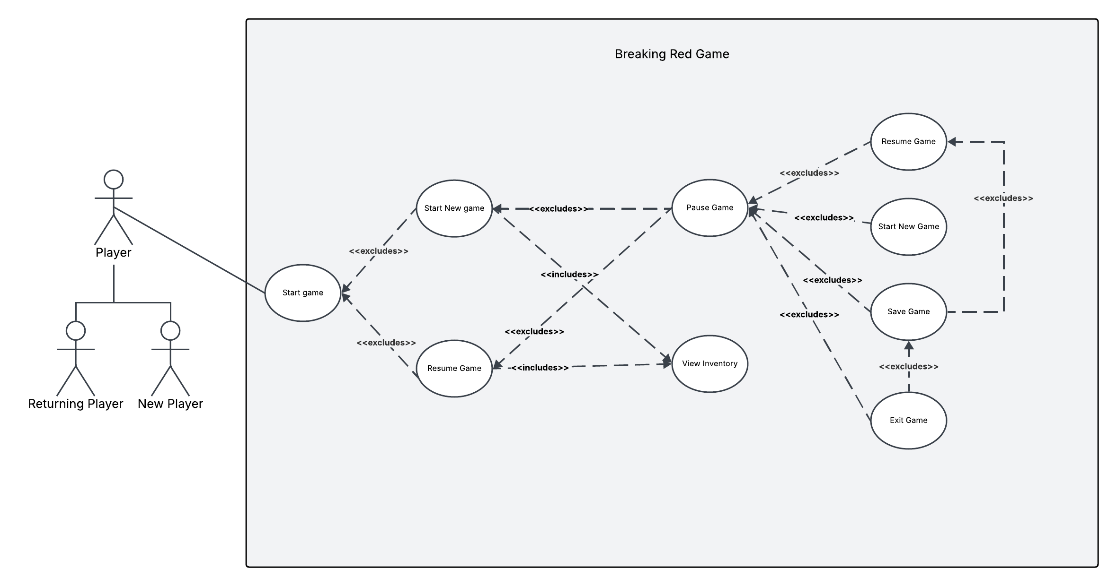

**Scenario #1**

**Name:** Start Game

**Summary:** The *Breaking Red* game loads and the player will see the menu screen before starting the game.

**Actors:** Player

**Preconditions:** Game initialized.

**Basic Sequence:**

**Step 1:** Player selects Start Game button.

**Step 2:** Player begins playing the game.

**Exceptions:**

**Step 1:** Resume button selected; Pause menu is closed and the previous game session is resumed.

**Step 1:** Start New Game button selected; Pause menu is closed and a new game session begins.

**Post conditions:** The game has begun.

**Priority:** 1 (Must have)

**ID:** 1

**Scenario #2**

**Name:** Pause Menu Called

**Summary:** The player pauses the game, pause menu appears.

**Actors:** Player

**Preconditions:** Player has already started playing the game.

**Basic Sequence:**

**Step 1:** Player triggers the pause function.

**Step 2:** Pause menu is displayed.

**Step 3:** Player makes a selection from the pause menu.

**Exceptions:**

**Step 3:** Player selects resume, the pause menu is closed and the game resumes.

**Step 3:** Player selects the Save Game button; the game progress and state is saved.

**Step 3:** Player selects Exit Game button; Pause menu closes and the game ends.

**Step 3:** Player selects Start New Game button; the Pause menu is closed, and a new game is started from the beginning.

**Post conditions:** Game has been paused by the player.

**Priority:** 2 (Essential)

**ID:** 2

**Scenario #3**

**Name:** Player saves the game.

**Summary:**  The Player chooses to save the game progress while the game is paused

**Actors:** Player

**Preconditions:** The Player paused the game.

**Basic Sequence:**

**Step 1:** Player triggers the pause function.

**Step 2:** Pause menu is displayed.

**Step 3:** Player selects Save Game button.

**Step 4:** The game progress and state are saved.

**Step 5:** Player makes another selection from the Pause menu.

**Exceptions:**

**Step 3:** Player selects Resume Game button; Pause menu closes and the game starts from the beginning.

**Step 3:** Player selects Start New game button; Pause menu closes and the game starts from the beginning.

**Step 3:** Player selects Exit Game button; Pause menu closes and the game ends.

**Post conditions:** The game progress is successfully saved.

**Priority:** 2 (Essential)

**ID:** 3

**Scenario #4**

**Name:** Player Starts a New Game.

**Summary:** The Player chooses to start a new game while the game is paused.

**Actors:** Player

**Preconditions:** The Player paused the game.

**Basic Sequence:**

**Step 1:** Player triggers the pause function.

**Step 2:** Pause menu is displayed.

**Step 3:** Player selects Start New Game button.

**Step 4:** The Pause menu closes.

**Step 4:** The game starts from the beginning.

**Exceptions:**

**Step 3:** Player selects the Save Game button; the game progress and state is saved.

**Step 3:** Player selects Exit Game button; Pause menu closes and the game ends.

**Step 3:** Player selects Resume button; the Pause menu is closed the game resumes.

**Post conditions:** The game progress is successfully saved.

**Priority:** 2 (Essential)

**ID:** 4

**Scenario #5**

**Name:** Player exits the game.

**Summary:**  The Player chooses to exit the game while the game is paused

**Actors:** Player

**Preconditions:** The Player paused the game.

**Basic Sequence:**

**Step 1:** Player triggers the pause function.

**Step 2:** Pause menu is displayed.

**Step 3:** Player selects Save Game button.

**Step 4:** The game progress and state are saved.

**Step 5:** Player makes another selection from the Pause menu.

**Exceptions:**

**Step 5:** Player selects Start New game button; the game starts from the beginning.

**Step 5:** Player selects Resume Game button; Pause menu closes and the game resumes.

**Step 5:** Player selects the Save Game button; the game progress and state is saved

**Post conditions:** The game progress is successfully saved.

**Priority:** 2 (Essential)

**ID:** 5

**Scenario #6**

**Name:** Player views the character inventory.

**Summary:**  The Player chooses to exit the game while the game is paused

**Actors:** Player

**Preconditions:** The game has been initialized and the game has started.

**Basic Sequence:**

**Step 1:** Display the View Inventory button.

**Step 2:** Player selects the inventory button.

**Step 3:** Display the character’s inventory.

**Step 4:** Give Player an option to use the item.

**Step 5:** Use item and close the Inventory,

**Exceptions:**

**Step 2:** Player selects close inventory and does not use an time: inventory screen closed.

**Post conditions:** Item has been used by the player.

**Priority:** 2 (Essential)

**ID:** 6

**Data Flow diagram from level 0 to process description for feature.**

In the data flow diagrams below, I will be covering the Menu and User Interface Feature entirely.

**Context Diagram**

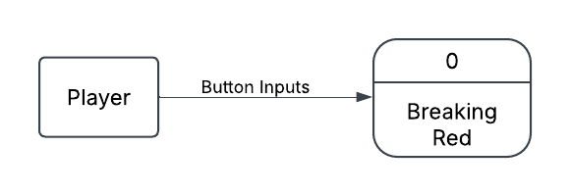

**Data Flow Diagram 0**

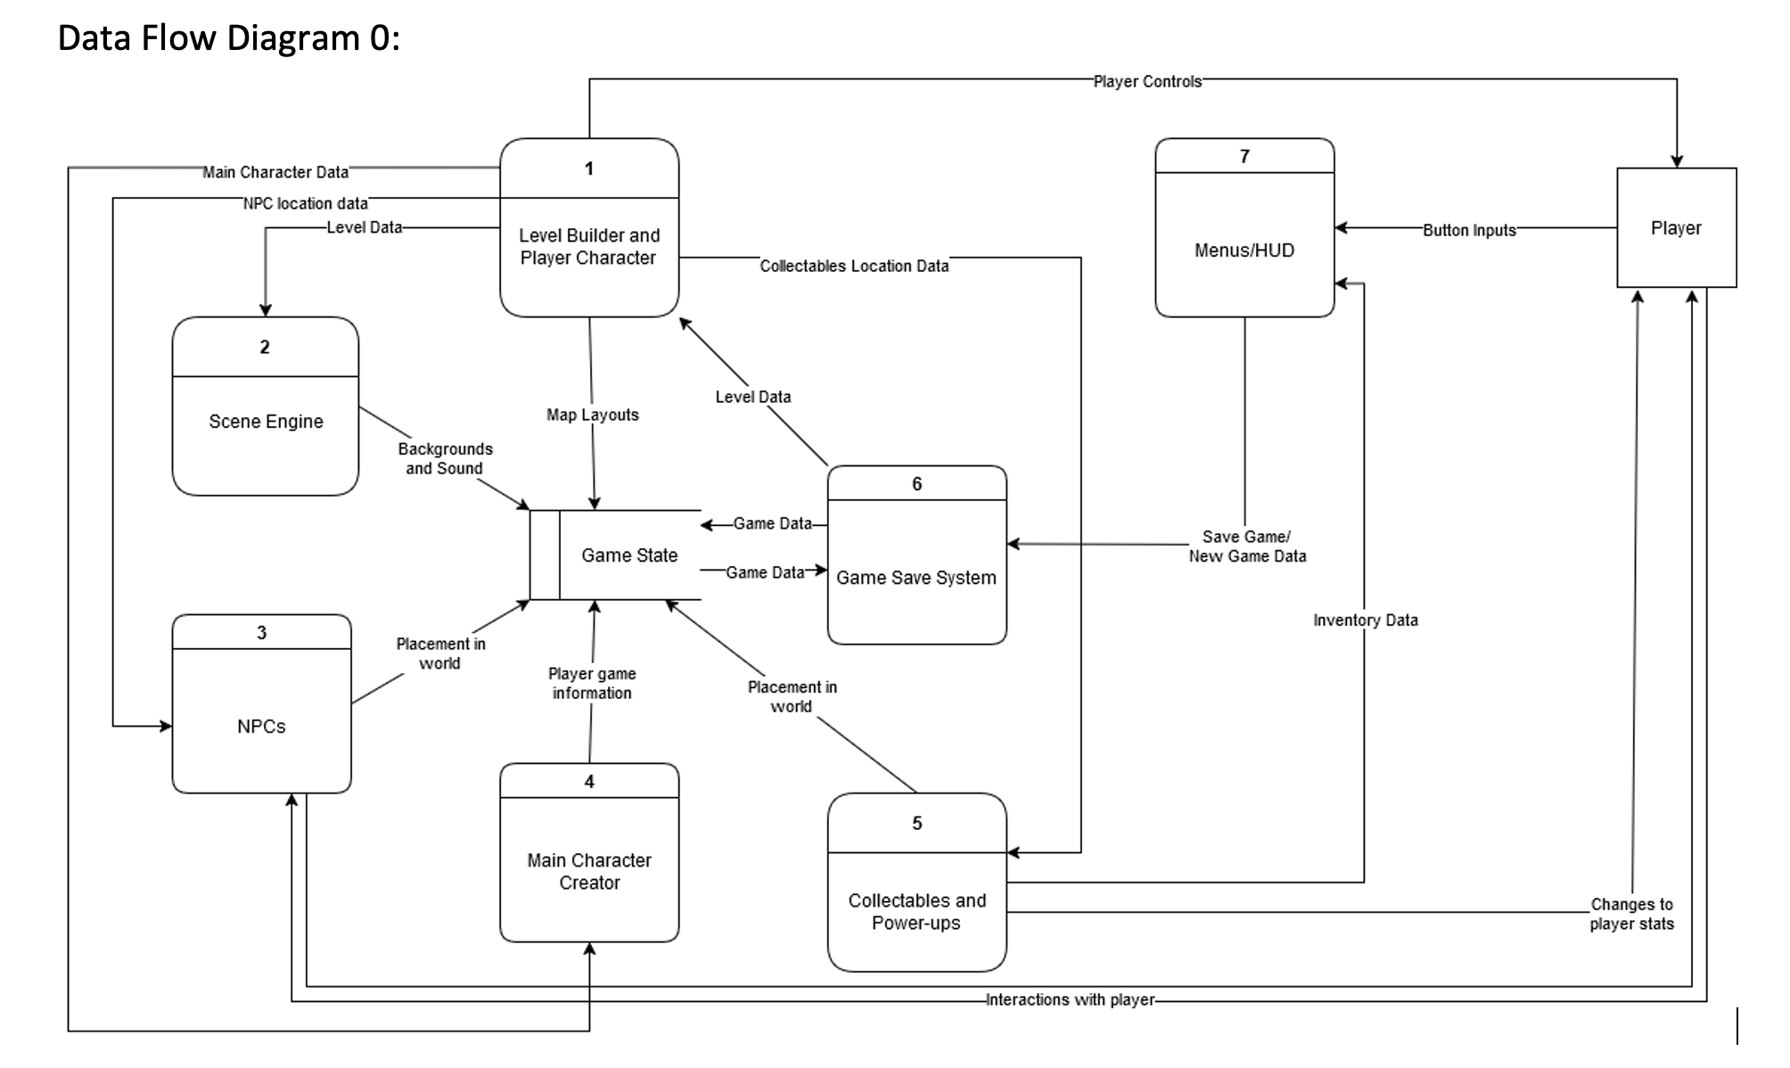

**Data Flow Diagram Level 1**

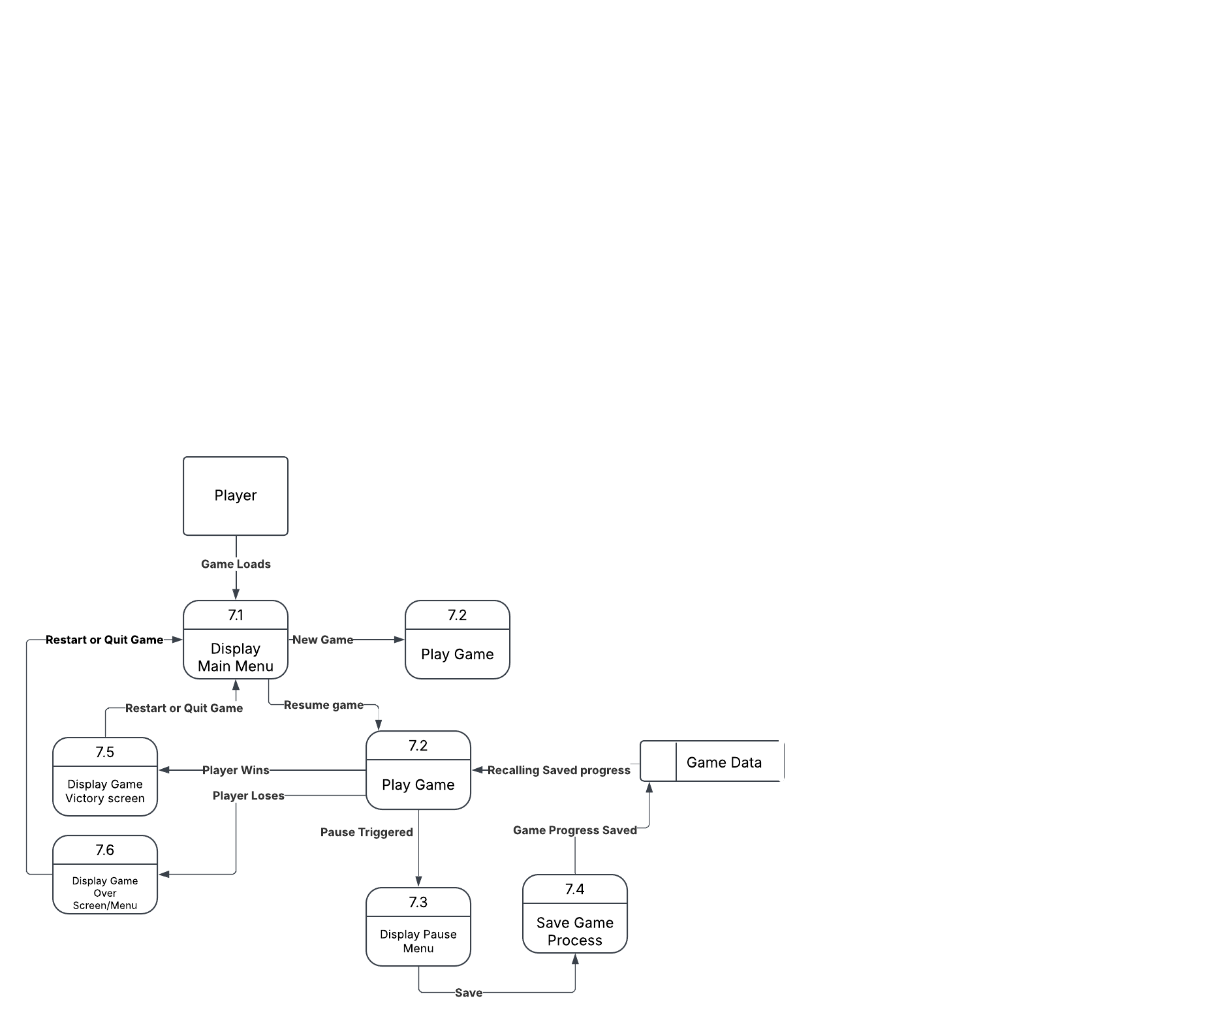

**Process Description**

Display Main Menu:

Accept Player menu selection

Display Main Menu

If player selection == Start game:

Game starts from beginning

Else if Player selection == resume game:

Game state = Game data

Game starts

Else player selection == quit game:

Application.Quit()

Play Game:

If new Player:

game begins from beginning

If returning player:

game starts at a saved state.

Display Pause Menu:

If game started:

if isPaused:

display pause menu

if resume selected:

isPaused == false; //game resumes

if exit game selected:

Quit.Application()

if save selected:

SaveGame();

if start new selected:

game starts at 0

Save Game Process:

Save game level

Save player stats

Save player position

Display Game Victory Screen:

If winConditions == true:

display victory screen

Else:

game continues

Display Game Over Screen:

If loseConditions == true:

display game over screen

if Main Menu selected:

Main Menu displayed

if quit game selected:

Quit.Application()

**Acceptance Tasks**

1. Game Navigation:
   1. All buttons using different input devices lead to the correct screen.
2. Visual Clarity Tests:
   1. Text and buttons are legible.
   2. Buttons change appearance when hovered over, selected and clicked.
3. Input and Accessibility Tests:
   1. Ensure all buttons work with various input devices.

**Timeline**

Work Items:

|  |  |  |
| --- | --- | --- |
| Task | Duration (Hours) | Predecessor Task(s) |
| 1. Requirements | 5 |  |
| 1. Creating Visual Main Menu Screen | 3 |  |
| 1. Coding Main Menu behavior scripts | 2 | 1, 2 |
| 1. Creating Pause menu Screen | 2 | 1 |
| 1. Coding Pause menu behavior and scripts | 3 | 1, 4 |
| 1. Creating inventory button and menu | 2 | 1, 4, 5 |
| 1. Coding Inventory button behavior script | 3 | 1, 4, 5, 6 |
| 1. Designing Victory Screen | 1 | 1 |
| 1. Coding Victory Screen behavior scripts | 3 | 1, 8 |
| 1. Designing Game Over Screen | 1 | 1 |
| 1. Coding Game Over screen behavior scripts | 3 | 1, 10 |
| 1. Testing | 4 | 1, 2, 3, 4, 5, 6, 7, 8, 9, 10, 11 |

**Pert Diagram**

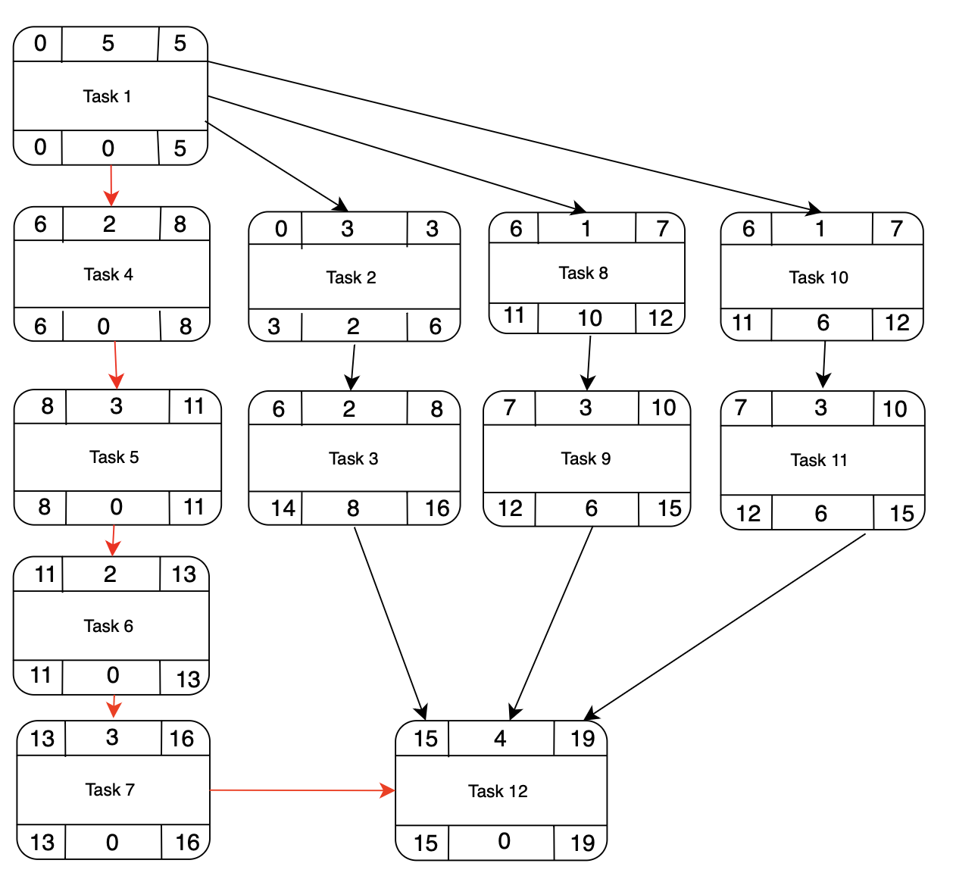 Tasks with red arrows are the critical path.

**Gantt Timeline**

